1. Enable cloudtrail monitoring and store the events in s3 and cloudwatch log events.

--- create one cloudtrail

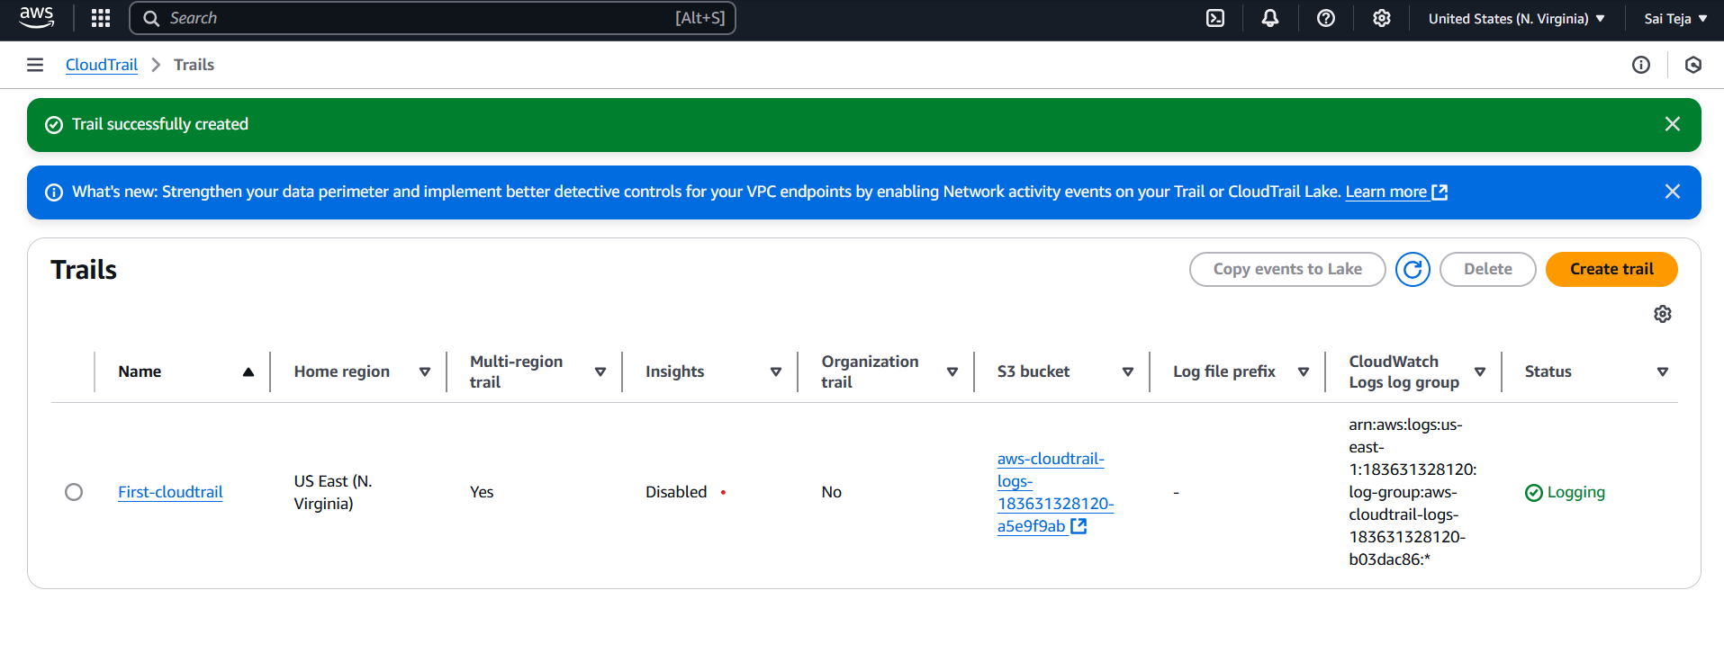

---one s3 bucket has been created

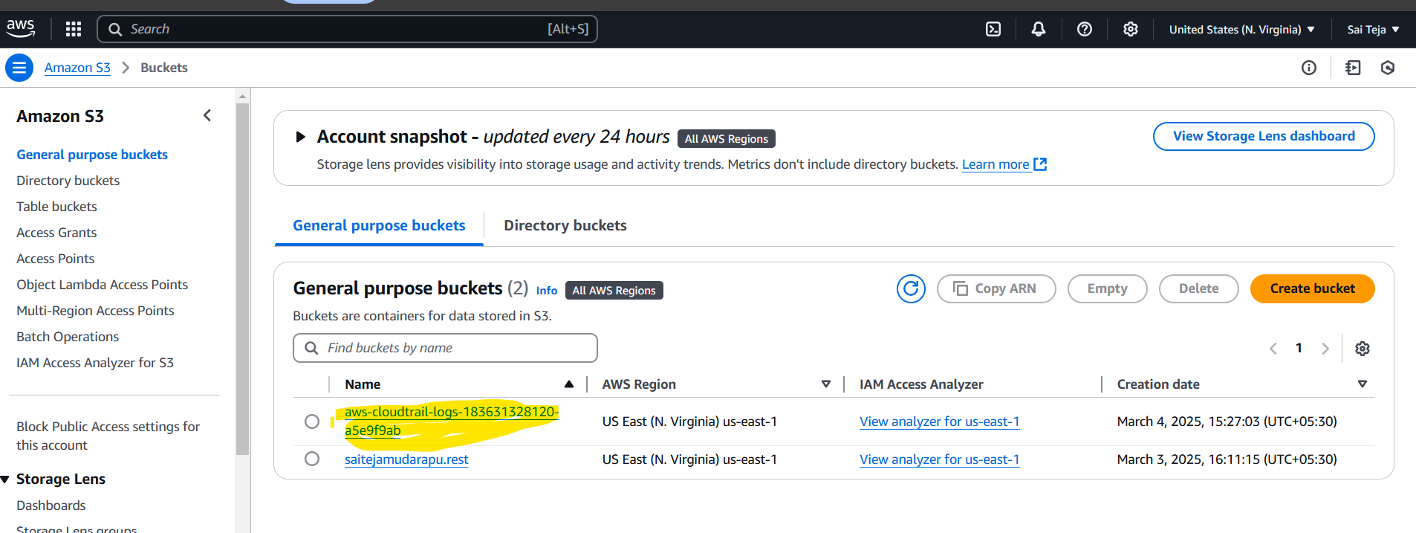

---- if we go inside the bucket we can find logs

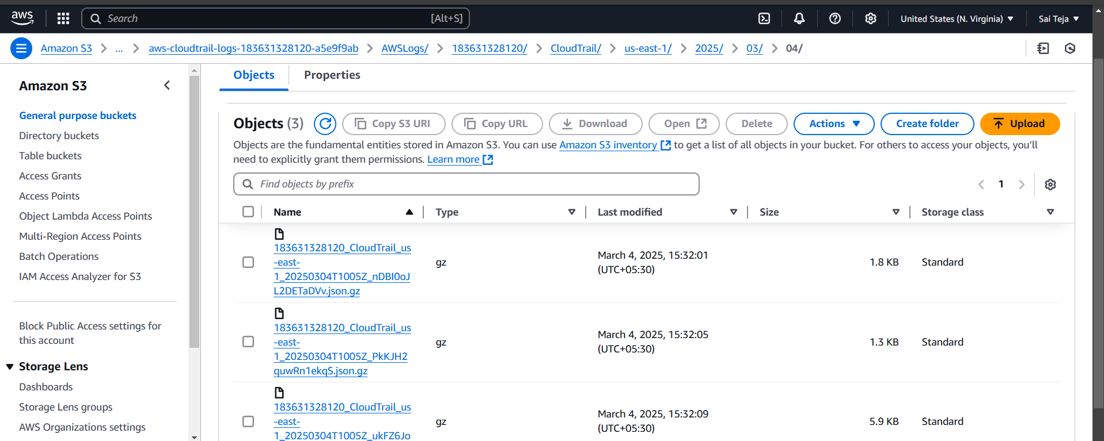

-------created one cloudwatch

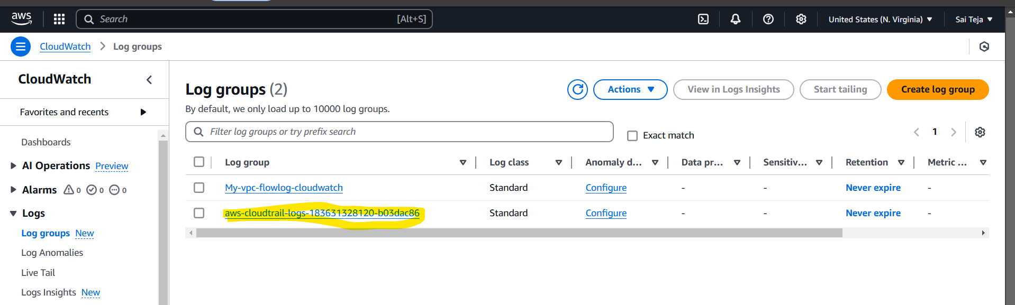

---- if we go inside the cloudwatch we can find the logs

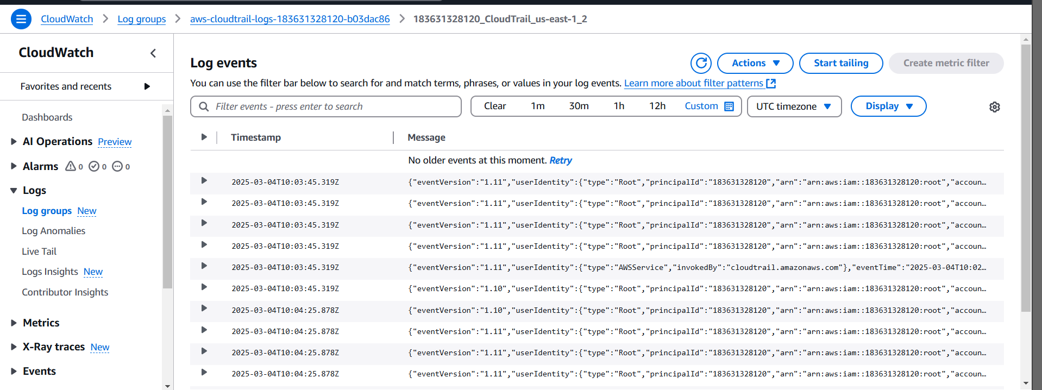

1. Enable SNS for cloudtrial to send alert on email.

----- go to SNS service , create new topic

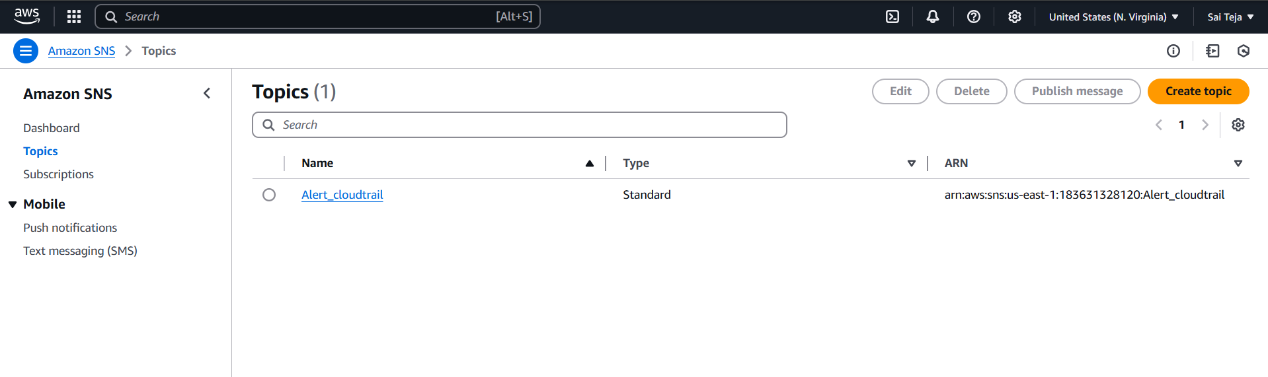

------ provide subscriptions to the created topic and need to confirm on provided email to get subscriptions confirmed

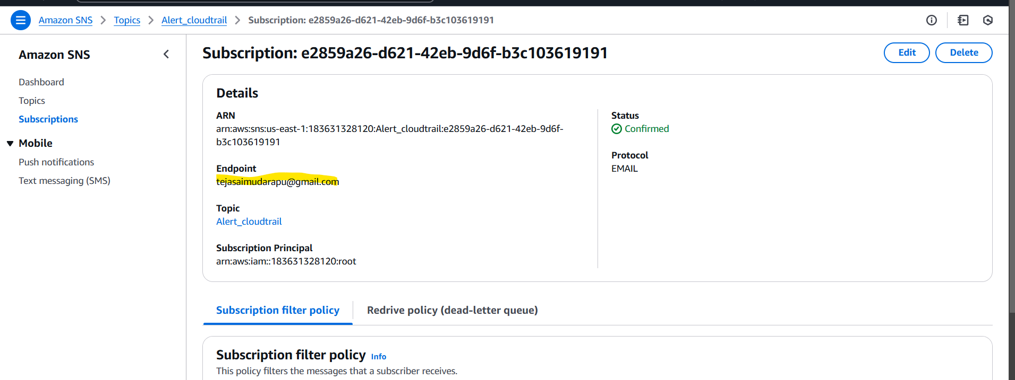

----- onces this done we can find the validation message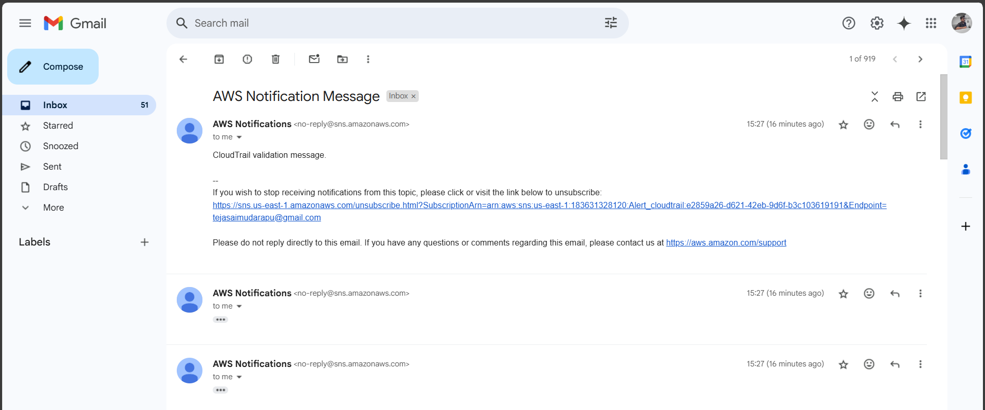

1. Configure cloud watch monitoring and record the cpu utilization and other metrics of ec2.

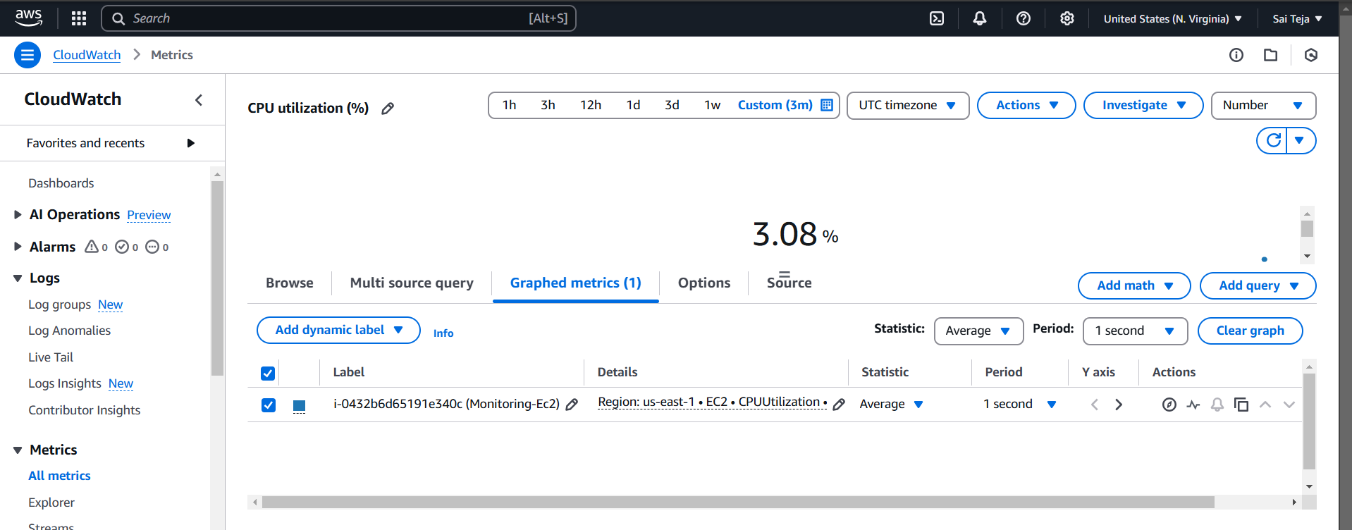

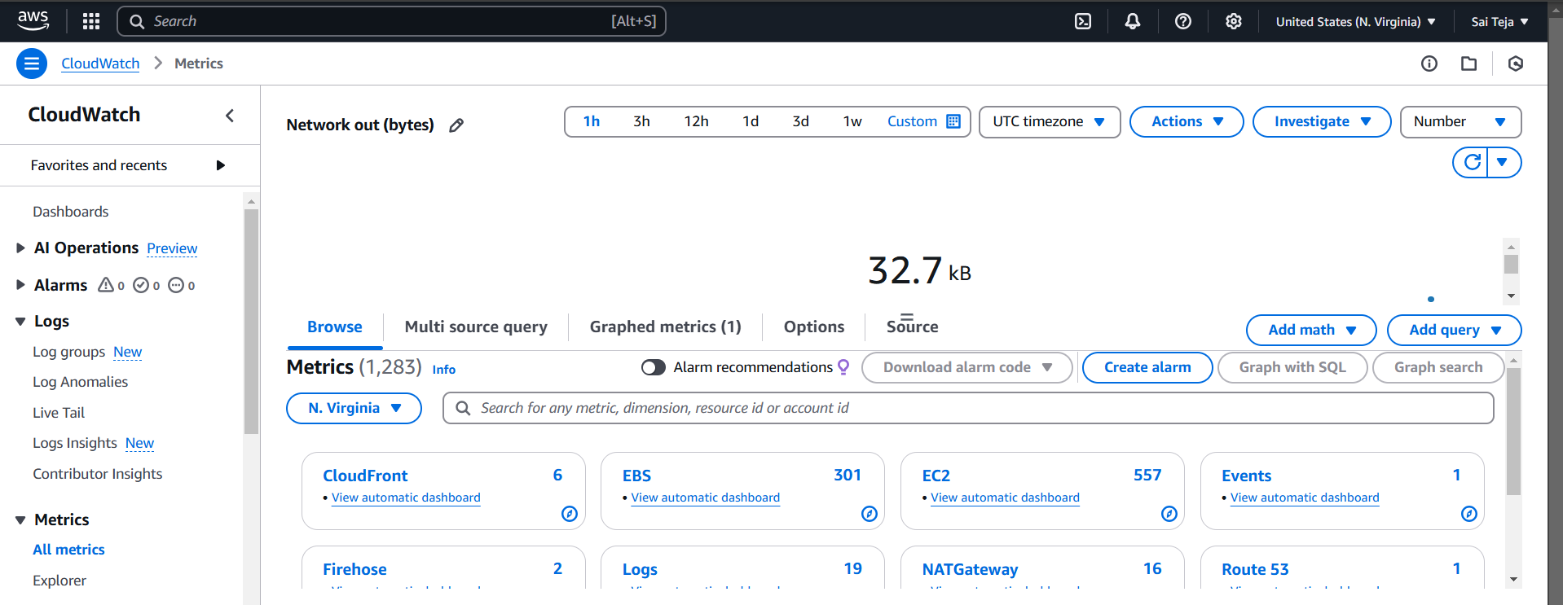

1. Create one alarm to send alert to email if the cpu utilization is more than 70 percent.

--created one alarm with name cpu reached 70%

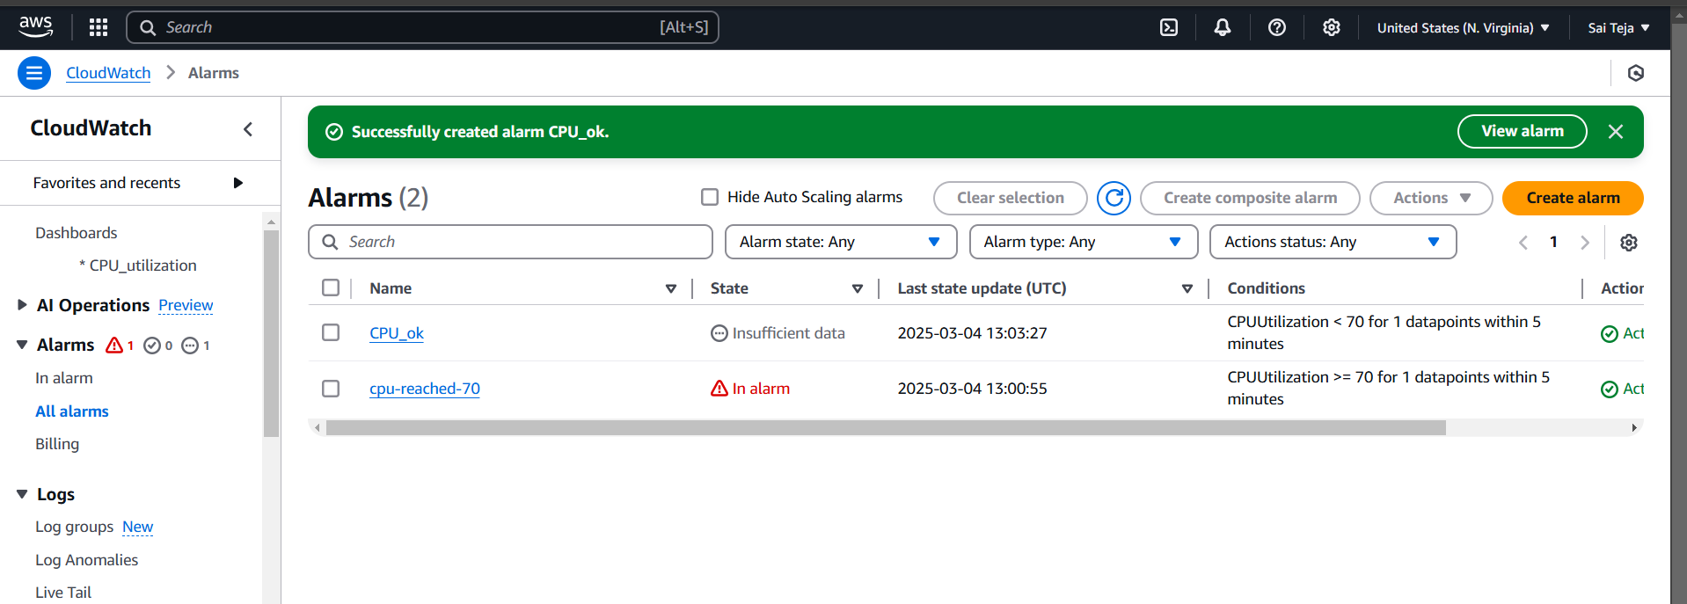

-----present cpu utilization

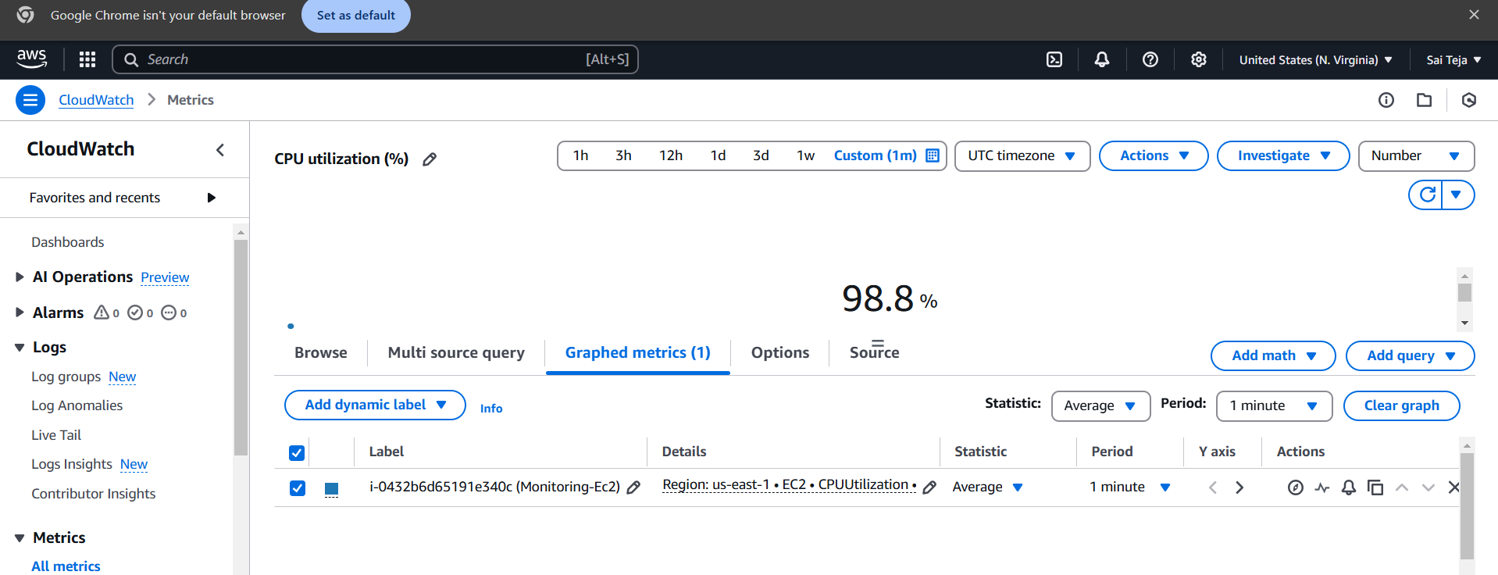

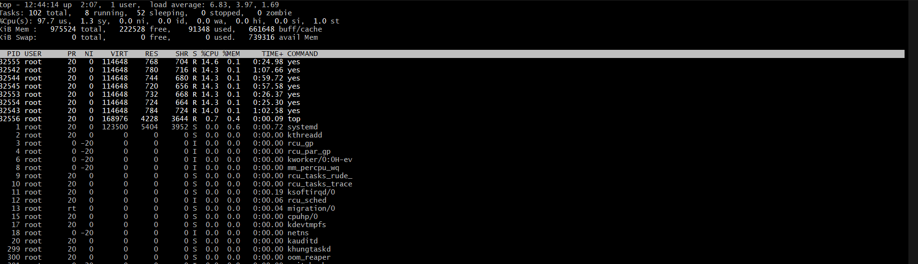

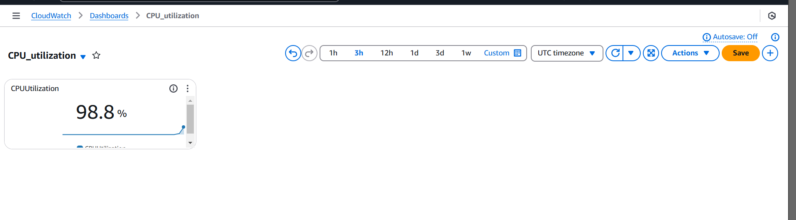

----- created alarm to send alert to email if the cpu utilization is more than 70 percent

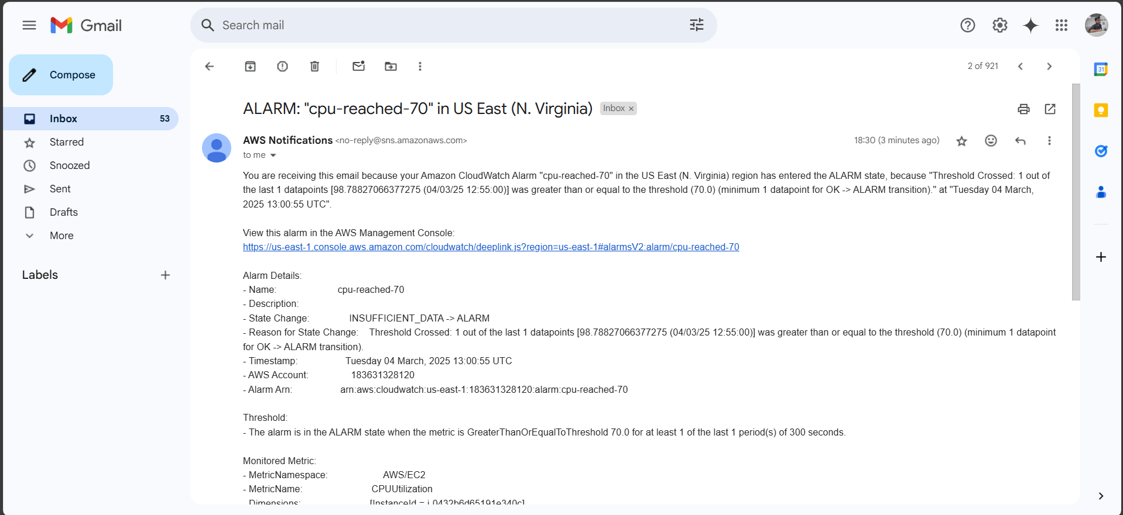

1. Create Dashboard and monitor tomcat service wether it is running or not and send the alert.

----- install tomcat service   
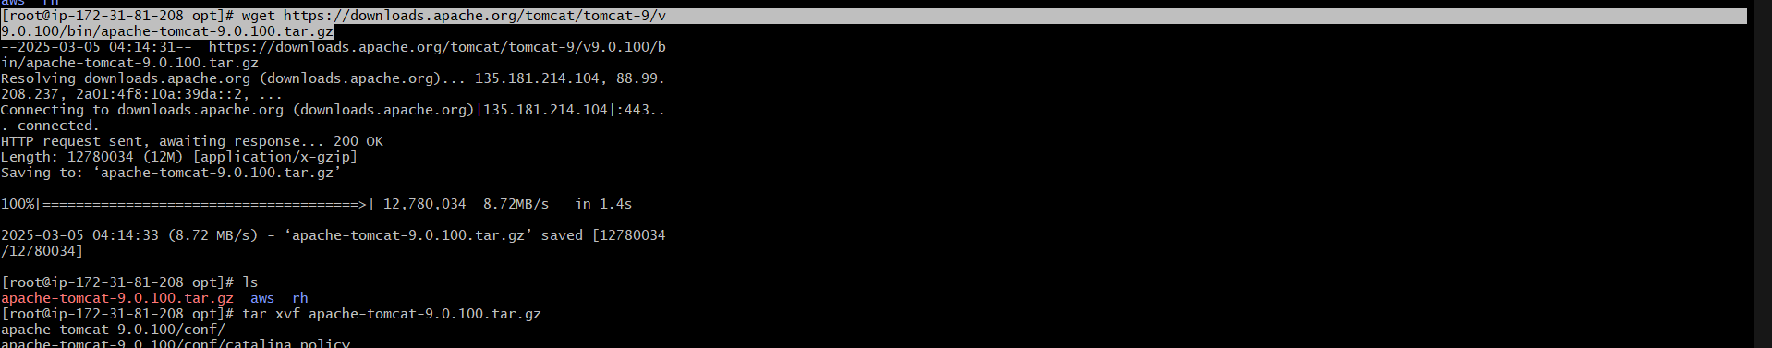

------ start the tomcat service



----- run the monitoring.bash and provide the permissions   
----- provide crontab to tomcat service to run every 1 min

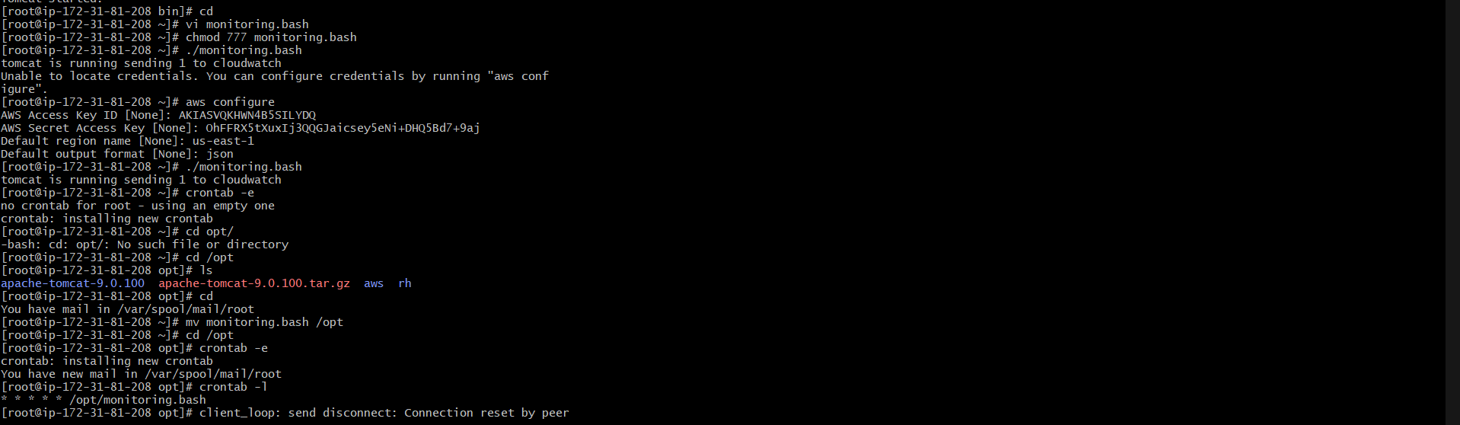

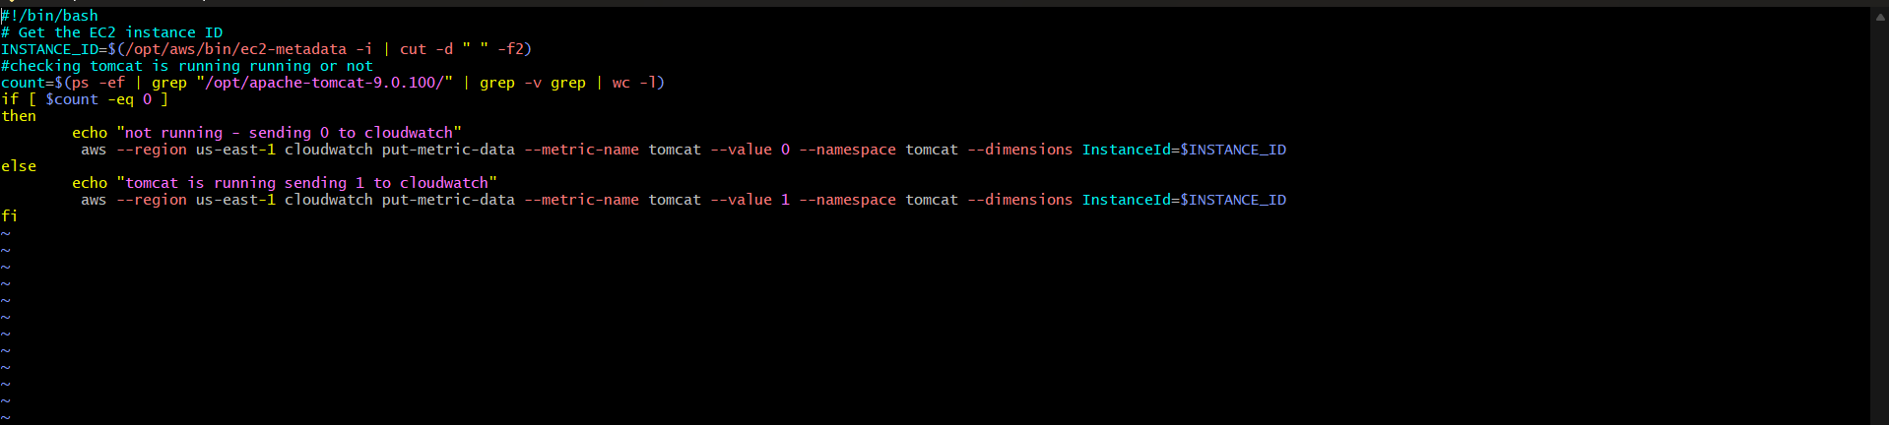

---- now create dashboard and check weather tomcat service is running if it is running it display 1 in dashboard

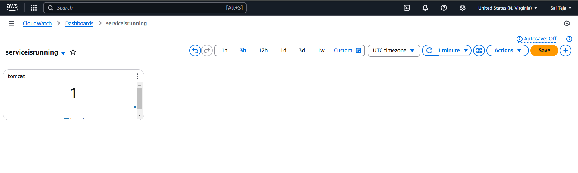

--- create the alarm to tomcat service i.e if tomcat is shutdown the alarm should trigger

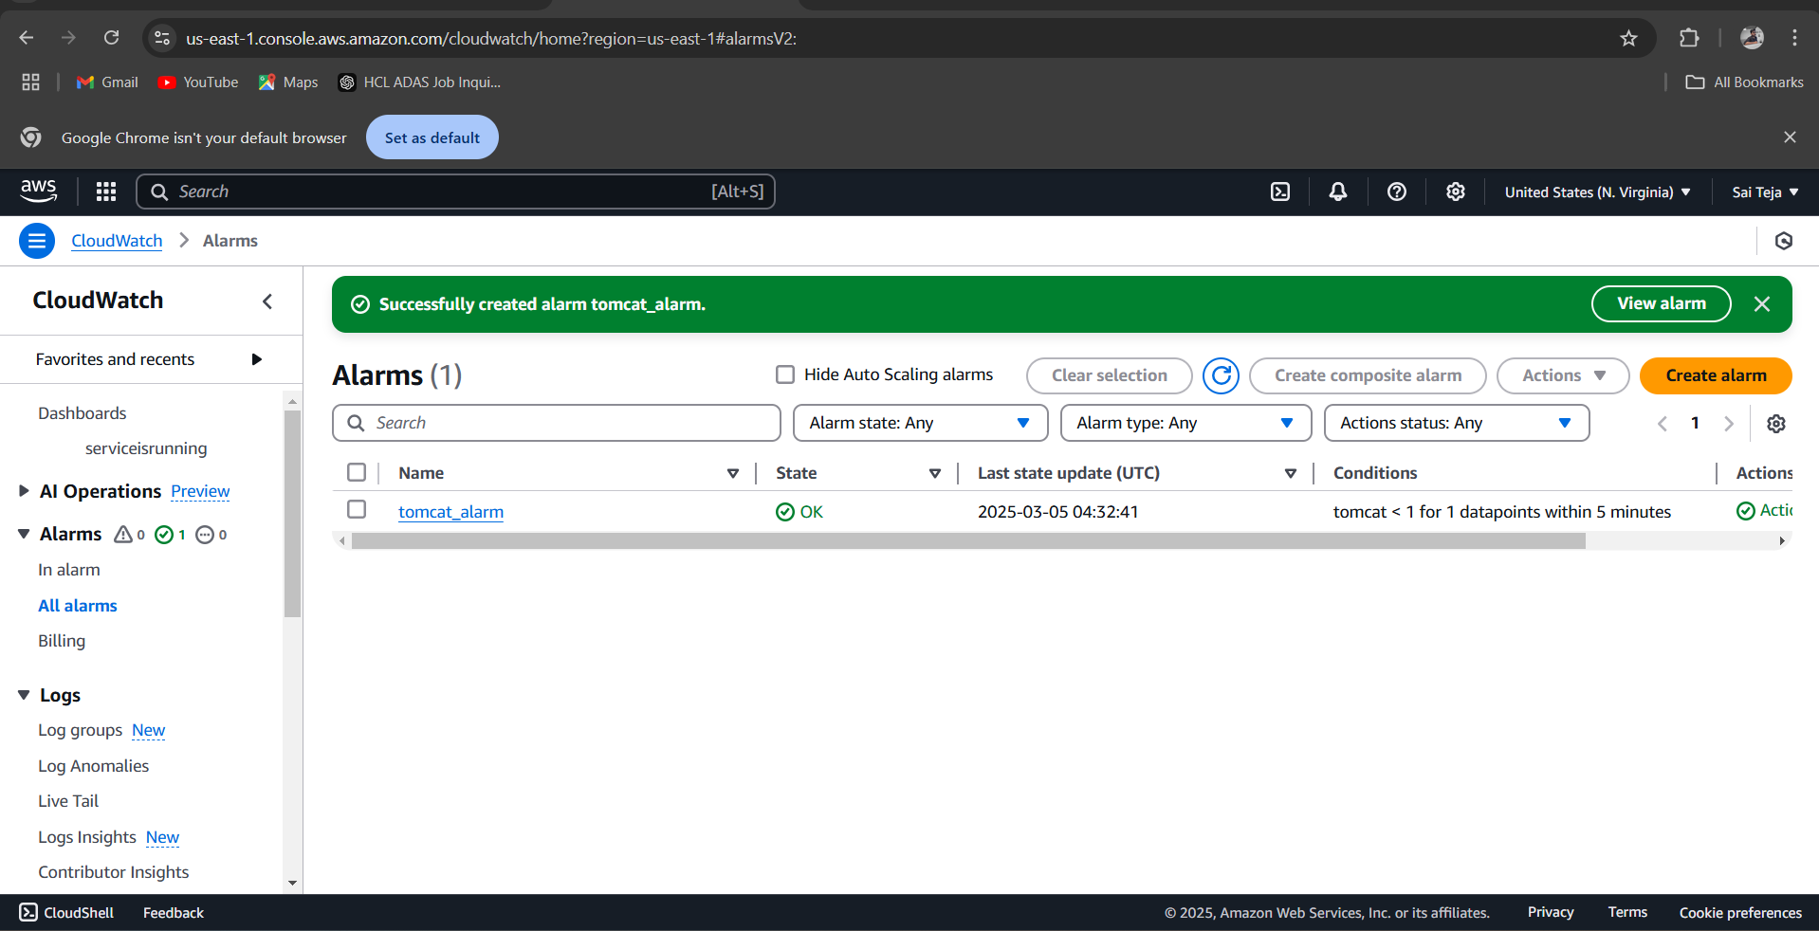

--- now shutdown the tomcat service , check the alarm is triggered or not

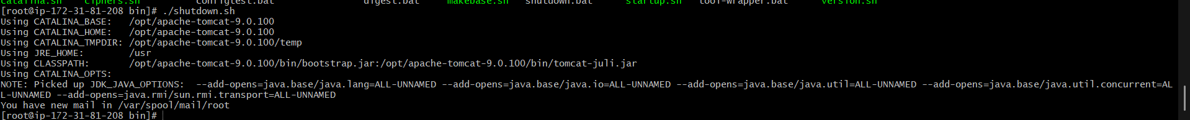

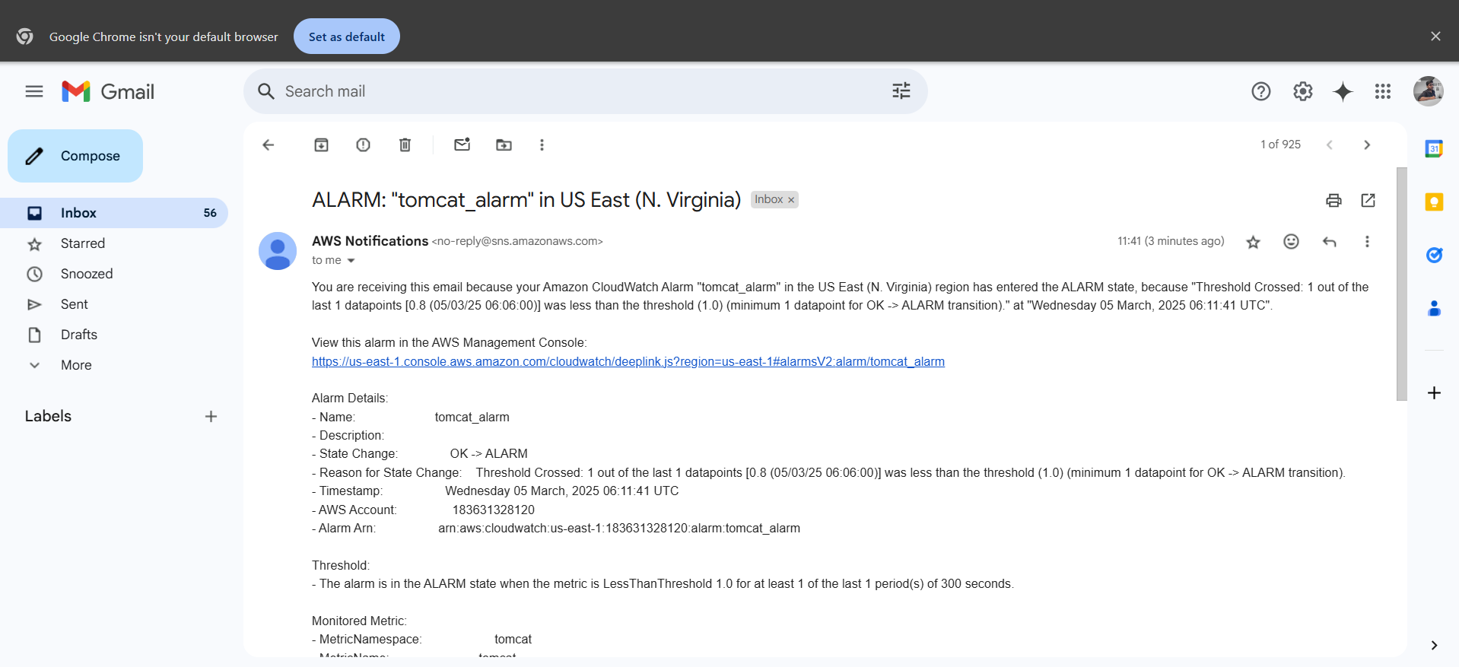

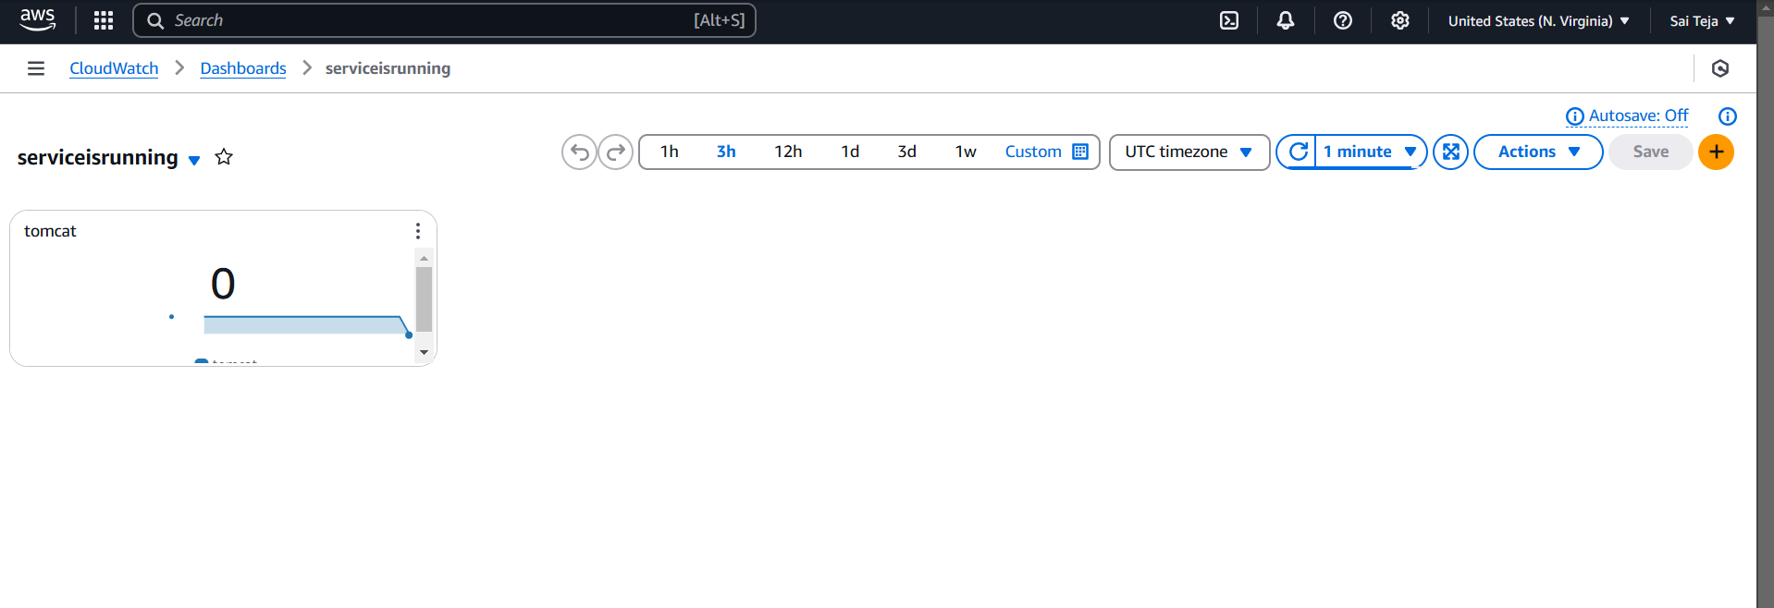

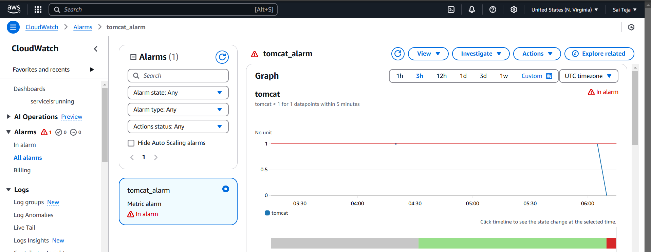

1. Create Dashboard and monitor nginx service to send the alert if nginx is not running.

----- install nginx service

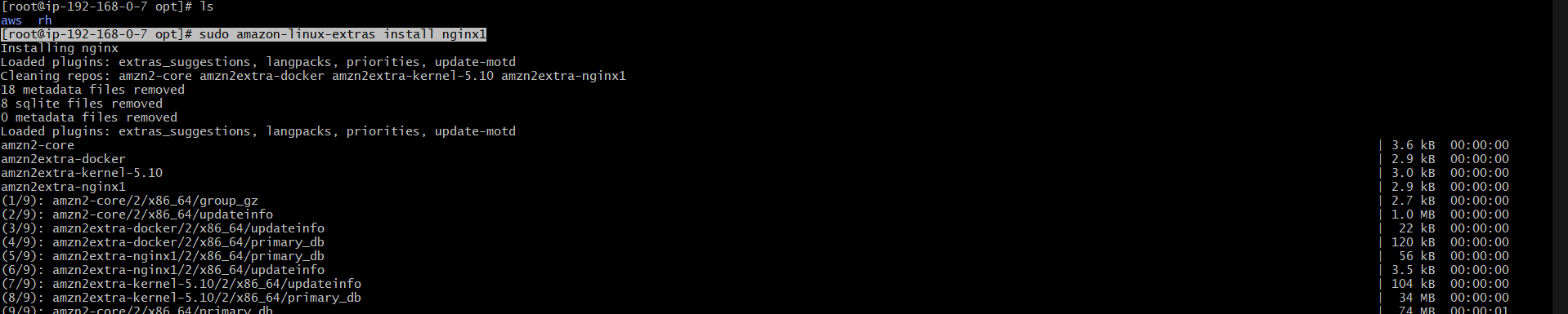

------ start the nginx service

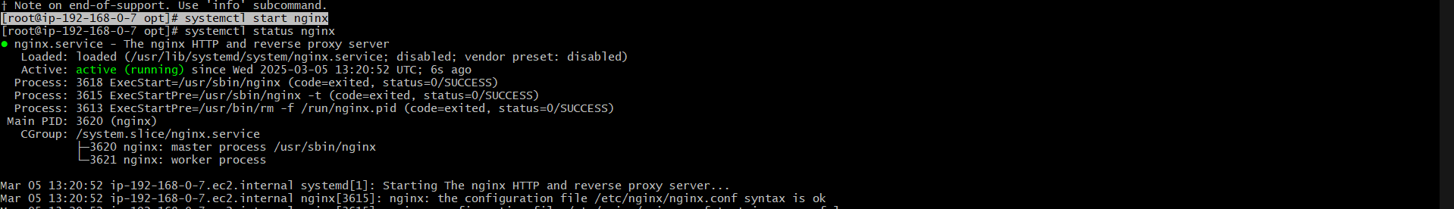

----- run the monitoring.bash and provide the permissions   
----- provide crontab to nginx service to run every 1 min

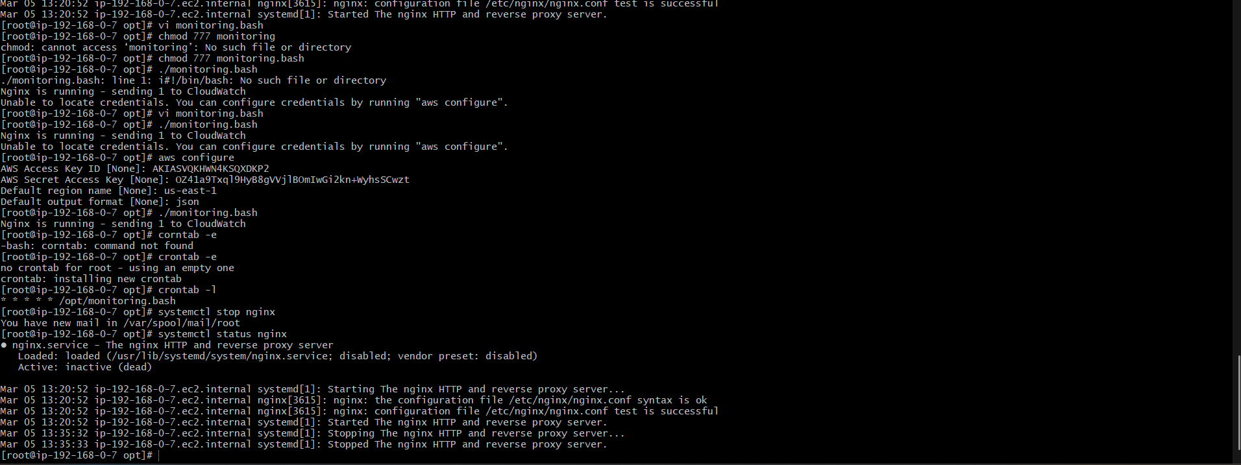

--script used

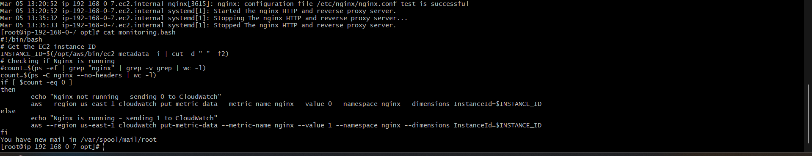

---- now create dashboard and check weather nginx service is running if it is running it display 1 in dashboard

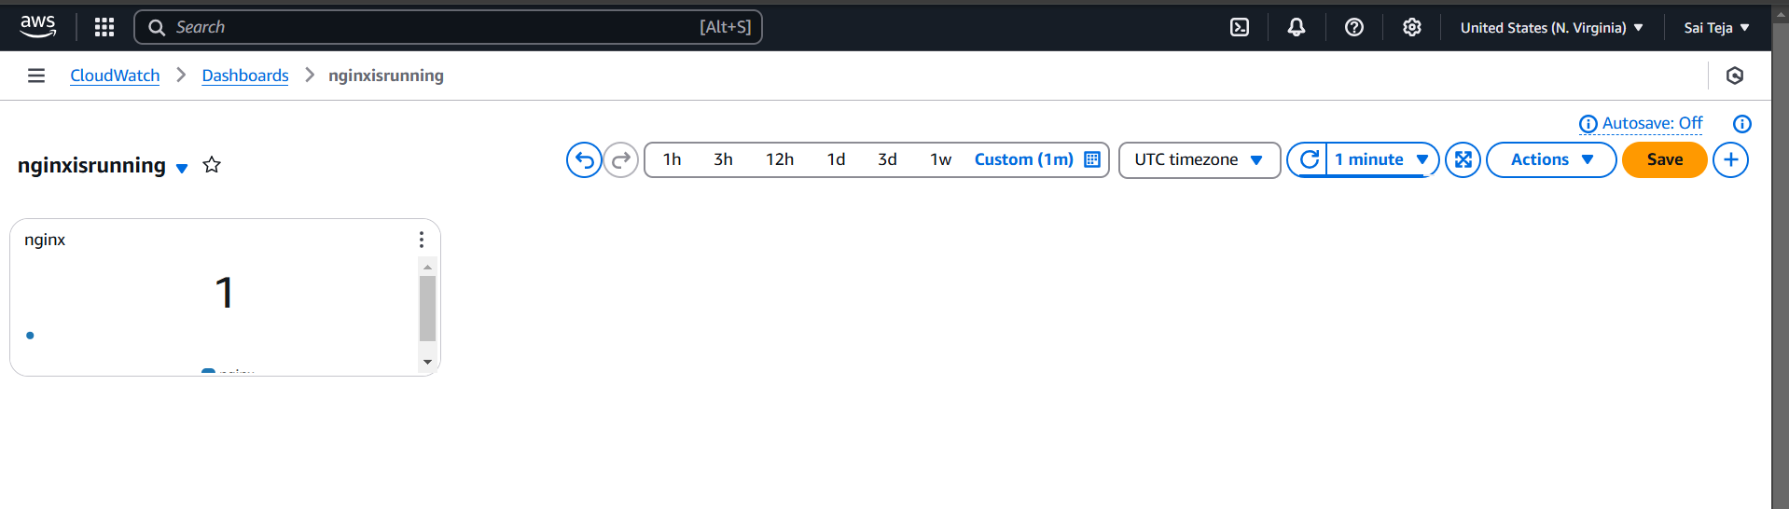

--- create the alarm to tomcat service i.e if tomcat is shutdown the alarm should trigger

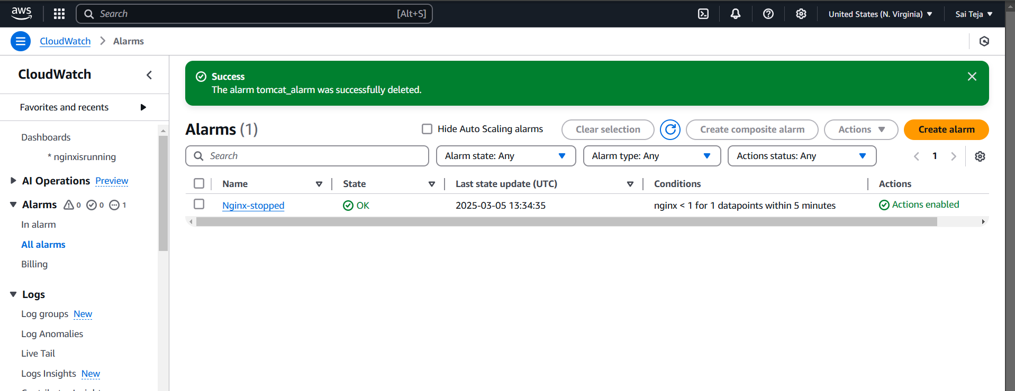

--- now shutdown the tomcat service , check the alarm is triggered or not

